# **Road Accident Dashboard Training Document (Excel-Based)**

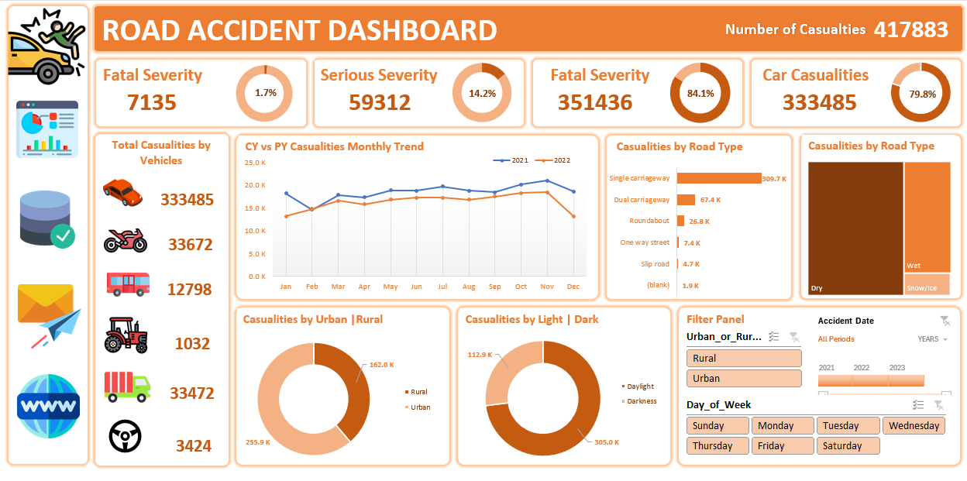

## Purpose of the Dashboard

This dashboard is created to **analyze and visualize road accident data** across different factors such as accident severity, vehicle type, road type, lighting condition, and area type (urban/rural). It helps in identifying patterns and supporting data-driven decision-making for road safety initiatives.

## Step-by-Step Structure to Build the Dashboard

### **PART 1: Primary KPIs Section**

**What we are making:**

Visual blocks with key performance indicators (KPIs) to give a quick summary.

**🔧 KPIs to Create:**

1. **Total Casualties**
2. **Fatal Casualties (Severe Deaths)**
3. **Serious Casualties (Critical Injuries)**
4. **Slight Casualties (Minor Injuries)**
5. **Casualties by Cars**

**Visualizations:**

* Use **number cards** (big bold values)
* Add **donut charts** (Data Labels ON, No Legends, % formatting)
* Insert **icons or shapes** to visually represent each KPI

### **PART 2: Secondary KPIs – Casualties by Vehicle Type**

**What we are making:**

A summary of casualties grouped by type of vehicle.

**🔧 Vehicle Groups:**

* Cars
* Motorcycles
* Buses
* Trucks
* Tractors
* Others

**Visualizations:**

* Use **icon + label** combinations (SmartArt or manual shapes)
* Add small **number cards** below or beside each icon
* Use **shapes or images** of vehicle types from Excel Icons or Insert → Pictures

### **PART 3: CY vs PY Casualty Trend (Monthly)**

**What we are making:**

A line chart comparing current year (CY) vs previous year (PY) month-wise data.

**Visualizations:**

* Use **Line Chart**
* X-axis: Month names (Jan to Dec)
* Y-axis: Casualty numbers
* Use two series: one for 2021, one for 2022
* Add **Data Labels and Legend**

### **PART 4: Casualties by Road Type**

**What we are making:**

Compare accident counts across different road types.

**Visualizations:**

* Use **Horizontal Bar Chart**
* Categories: Single carriageway, Dual carriageway, Roundabout, One-way, Slip road, etc.
* Sort by descending order

### **PART 5: Casualties by Road Surface Condition**

**What we are making:**

Show how many casualties occurred on dry, wet, or snow-covered roads.

**Visualizations:**

* Use **Tree Map** or **100% Stacked Bar**
* Categories: Dry, Wet, Snow/Ice

### **PART 6: Urban vs Rural Casualties**

**What we are making:**

Compare how many accidents happened in Urban vs Rural areas.

**Visualizations:**

* Use **Donut Chart**
* Two categories: Urban, Rural
* Highlight with contrasting colors (e.g., brown vs light beige)

### **PART 7: Light Condition Analysis (Day vs Night)**

**What we are making:**

Determine when most accidents happen — during daylight or darkness.

**Visualizations:**

* Use **Donut Chart**
* Categories: Daylight, Darkness
* Show both count and percentage

### **PART 8: Filter Panel**

**What we are making:**

Interactive panel to filter data based on:

1. **Urban or Rural**
2. **Years (2021, 2022, 2023)**
3. **Day of Week (Mon–Sun)**

**Visualizations:**

* Use **Slicers** (Insert > Slicer from Pivot Table)
* Style them with custom colors matching your theme

### **PART 9: Linked Image Navigation**

**What we are making:**

Clickable icons that navigate to the dataset or pivot pages.

**How to do it:**

1. Insert image or icon (Insert > Icons or Pictures)
2. Right-click > Link > Place in this Document > Select Sheet (e.g., Dataset)
3. Add a small hover effect using formatting

### **Data Setup Recommendation**

* Use **Pivot Tables** behind all visuals
* Store raw data in one clean sheet (RoadAccidentData)
* Name your ranges or use Excel Tables
* Use helper columns (e.g., Year, Month, Light, Road Type Group) for better analysis

### **Tools & Features Used**

|  |  |
| --- | --- |
| Feature | Use Case |
| Pivot Tables | Aggregating accident data |
| Pivot Charts | Creating dynamic visuals |
| Donut Charts | For % comparison |
| Line Charts | Time-series (month) analysis |
| Bar Charts | Category-wise comparisons |
| Slicers | Interactive filtering |
| Shapes/Icons | Visual storytelling & linking |
| Conditional Formatting | For color indicators |